***Covid Patient Management System***

ABSTRACT :-

This project covid Management system includes registration of patients, storing their details into the system, and also computerized billing in the pharmacy, and labs. The software has the facility to give a unique id for every patient and stores the clinical details of every patient and hospital tests done automatically. It includes a search facility to know the current status of each patient. User can search details of a patient using the id. The covid Management System can be entered using a username and password. It is accessible either by an administrator or receptionist. Only they can add data into the database. The data can be retrieved easily. The interface is very user-friendly. The data are well protected for personal use and makes the data processing very fast.

OBJECTIVE :-

In order to create the covid management system feature list, you need to identify your priorities by choosing the benefits that are prior for your case.

1. Improved Processes. ...
2. Digital medical records. ...
3. Staff interaction. ...
4. Facility management. ...
5. Financial control and tax planning. ...
6. Market strategy. ...
7. Insurance claims processing.

STRUCTURE OF TABLES

**TABLE LIST IN PROJECT :-**

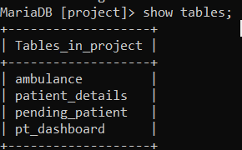

**PATIENT_DASHBOARD :-**

This table contain all the information of patient including their

Name , mobile no. , age , report

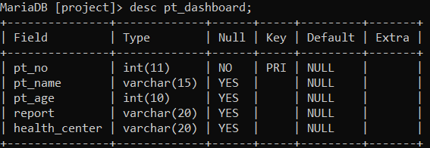

**PATIENT DETAILS :-**

This table contain all the information of patient including their

Name , mobile no. , age , addrese .

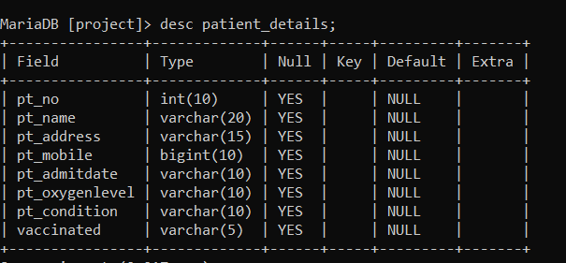

AMBULANCE :-

This table contain all the information of patient including their

Name , mobile no. , pickup location , drop location .

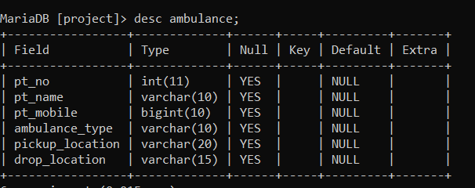

**PENDING PATIENT :-**

This table contain all the information of patient including their

Name , mobile no. , age , reson .

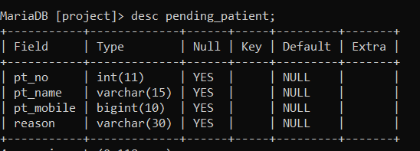

**CONTENT OF TABLES:-**

**PATIENT_DASHBOARD :-**

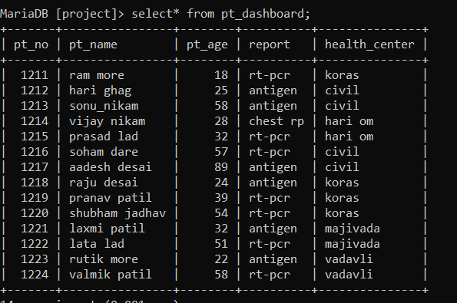

**PATIENT DETAILS :-**

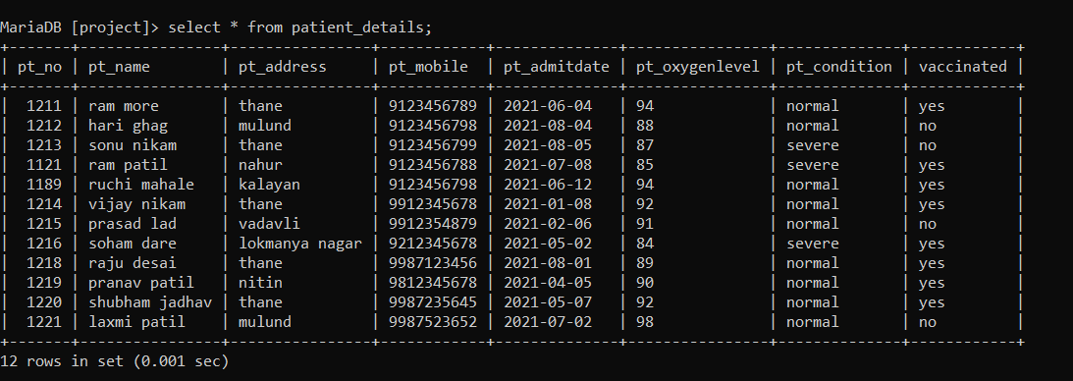

AMBULANCE :-

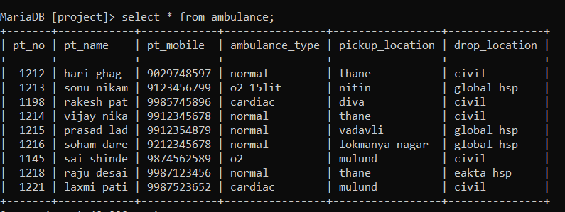

**PENDING PATIENT :-**

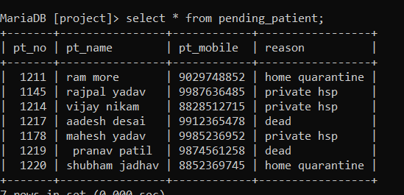

**CONSTRAINTS :-**

Unique key

A Unique key is a set of one or more than one fields or columns of a table that uniquely identify a record in a database table.

1. Show the pt_mobil no. as a unique key In ambulance table .

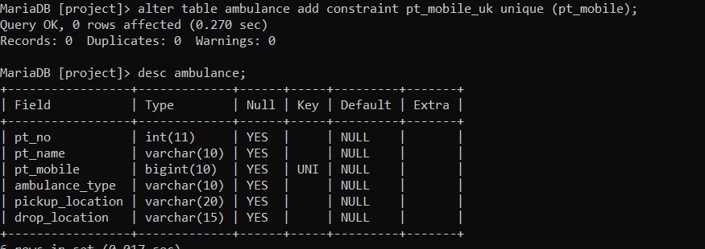

1. Show the pt_mobile no. as a unique key in pending_patient table.

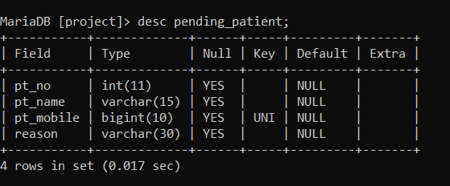

SUBQUERIES :-

* You can place the Subquery in a number of SQL clauses: WHERE clause, HAVING clause, FROM clause. Subqueries can be used with SELECT, UPDATE, INSERT, DELETE statements along with expression operator.
  1. select pt_no , pt_name from patient_details where pt_oxygenlevel in(select min(pt_oxygenlevel) from patient_details);

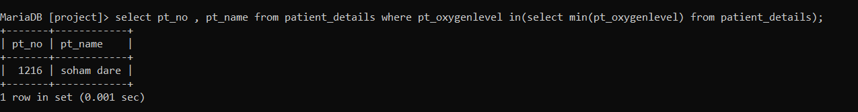

* 1. Select pt_no , pt_name , pt_age , report from pt_dashboard where pt_age in(select max(pt_age) from pt_dashboard);

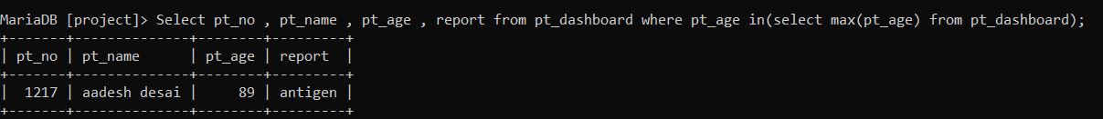

Views:-

* A view is a virtual table whose contents are defined by a query. Like a table, a view consists of a set of named columns and rows of data. Unless indexed, a view does not exist as a stored set of data values in a database.
  1. Create view pt_4 as select pt_no , pt_name ,pt_address , pt_admitdate ,pt_oxygenlevel from patient_details where pt_oxygenlevel >85;

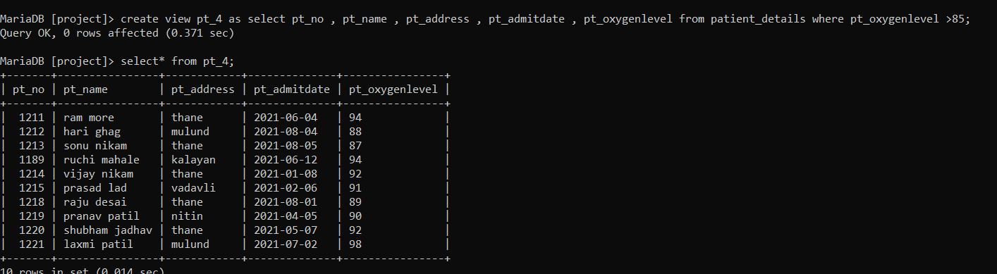

* 1. Create view pt_2 as select pt_name , pt_no , pt_mobile from pending_patient where pt_no>1200;

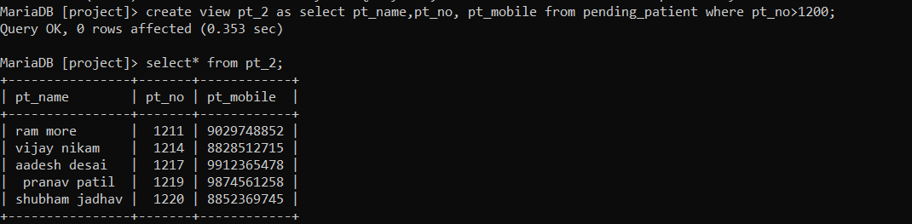

JOINS :-

A JOIN clause is used to combine rows from two or more tables, based on a related column between them. Let's look at a selection from the "Orders" table: Then, look at a selection from the "Customers" table:

1. SELECT * from patient details inner join pending_patient on patient_details.pt_name = pending_patient.pt_name;

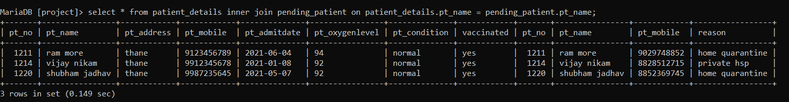

 Right join:-

1. Select * from patient_details right join pt_dashboard on patient_details.pt_no = pt_dashboard.pt_no;

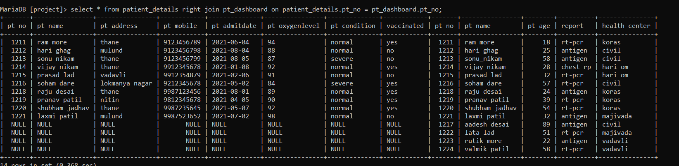

 Left join :-

1. Select * from ambulance left join pt_dashboard on ambulance.pt_name = pt_dashboard.pt_name;

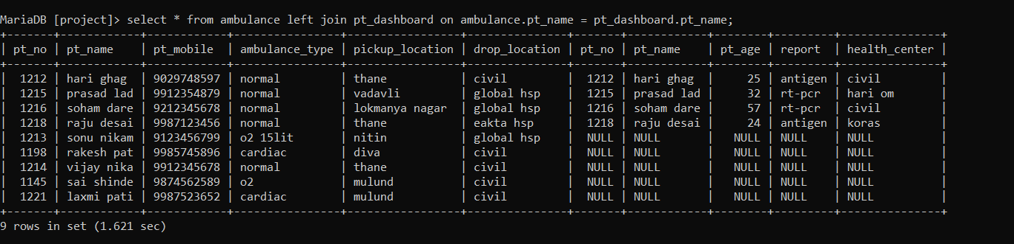

ER-DAIGRAM:-

AMBULANCE

PATIENT_DETAILS

PENDING_PATIENT

PT_NO

PT_NAME

PT_AGE

REPORT

HEALTH_CENTRE

PT_NO

PT_NAME

PT_AGE

AMBULANCE_TYPE

PICKUP_LOCATION

DROP_LOCATION

PT_NO

PT_NAME

PT_ADDRESS

PT_MOBILE

PT_ADMITDATE

PT_OXYGENLEVEL

PT_CONDITION

VACCINATED

PT_NO

PT_NAME

PT_MOBILE NO.

REASON

PT_***DASHBOARD***

PT_MOBILENO.

PT_ADMITDATE

PT_OXYGENLEVEL